**CS5590/490 Python-DeepLearning**

**Python**

**LAB**

**Assignment-1**

**Submitted by: Shajee Uddin Zain Mohammed**

**Student ID: 16230179**

**Class ID: 28**

**1) For any web application login, the user password need to be validated against database rules. For My UMKC web application following are the criteria for valid password:**

**a) The password length should be in range 6-16 characters**

**b) Should have atleast one number**

**c) Should have at least one special character in [$@!*]**

**d) Should have atleast one lowercase and at least one uppercase character**

**Use loops to write a python program for the above scenario.**

**Source Code:**

**import** re *#importing Regular expression for general expression patterns***def** validation(): *#defining a function* **while True**:  
 password = input(**"Enter a password for My UMKC : "**)  
 **if** len(password)< 6 **or** len(password) > 16: *#condition for length of the password* print(**"Please enter a characters only between 6-16 "**)  
 **elif** re.search(**'[0-9]'**,password) **is None**: *#condition for validation number* print(**"Please make sure your password contains atleast one number"**)  
 **elif** re.search(**'[$@!*]'**,password) **is None**: *#condition for insertion for charaters* print(**"Please make sure your password contains atleast one characters from [$@!*]"**)  
 **elif** re.search(**'[a-z]'**, password) **is None**: *#lower case* print(**"Please make sure your password contains atleast one lower case letter"**)  
 **elif** re.search(**'[A-Z]'**,password) **is None**: *#upper case* print(**"Please make sure your password contains atleast one upper case letter"**)  
 **else**:  
 print(**"Password accepted"**)  
 **break**validation()

**Output:**

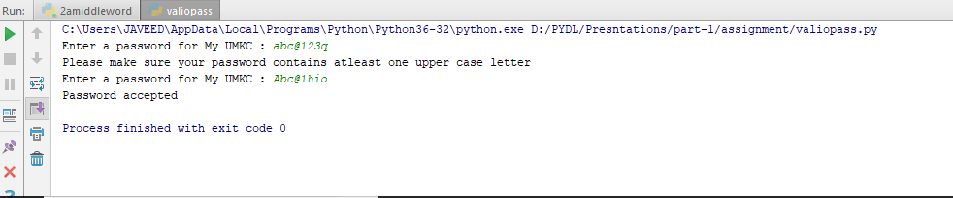

1. **Write a Python function that accepts a sentence of words from user and display the following**

**a) Middle Word**

**Source Code:**

senten = input(**"Enter a sentence:"**)  
**def** middle(x):  
 a = senten.split() *#spliting the sentence into list* length = len(a)  
 **if** length % 2 == 1: *#checking whether the sentence has odd number words* i = int(length/2) *# getting the postion of the middle word* print(**"The middle word is :"**a[i]) *# printing the middle word* **else**: *#if the number of word are even* i = int((length/2)-1) *#getting the postion of the middle two words* j = int(length/2)  
 print(**“the middle letters of the sentence are: “**,a[i],a[j]) *# print the middle two words since the sentence has even words*middle(senten)

**Output:**

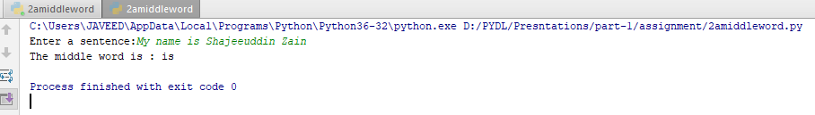

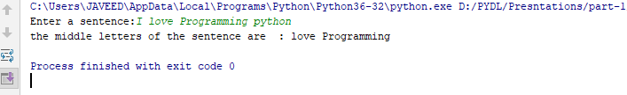

**b. Longest Word**

**Source Code:**

senten = input(**"Enter a sentence:"**)  
word_list = senten.split() *#spliting the sentence into list***def** find_longest_word(word_list): *#word_list is used to keep the list of the words* word_len = [] *#defining to keep the length of the words* **for** n **in** word_list:  
 word_len.append((len(n),n)) *# appending the length of the word and the word* word_len.sort() *# sorting words according to length* **return** word_len[-1][1]  
print(find_longest_word(word_list))

**Output:**

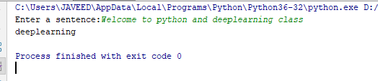

**c. Reverse Order**

**Source code:**

senten = input(**"Enter a sentence:"**)  
**def** reverse():  
 a = senten[::-1] *#reversing the given string and storing in different variable* b = a.split() *#spliting the sentence into list* print(**' '**.join(reversed(b))) *#reversed function used to reverse the string*reverse()

**Output:**

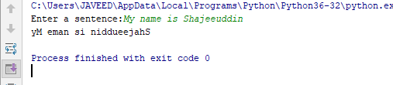

1. **Given a list of n number, write a Python program to find triplets in the list which gives the sum of zero.**

**Source Code:**

**def** findTriplets(arr, n):  
 found = **False** arr.sort() *# sorting elements of the array* **for** i **in** range(0, n - 1):  
 left = i + 1 *# initializing left and right* right = n - 1  
 x = arr[i]  
 **while** (left < right):  
 **if** (x + arr[left] + arr[right] == 0):  
 print([x, arr[left], arr[right]])*# print elements if sum is zero* left += 1  
 right -= 1  
 found = **True  
 elif** (x + arr[left] + arr[right] < 0):*# If sum of three elements is lessthan zero then increment in left* left += 1  
 **else**: *# if sum is greater than zero than decrement in right side* right -= 1  
 **if** (found == **False**):  
 print(**" No Triplet Found"**)  
  
a = input(**"Enter the list of numbers:"**)  
arr = list(map(int,a.split()))  
n = len(arr)  
findTriplets(arr, n)

**Output:**

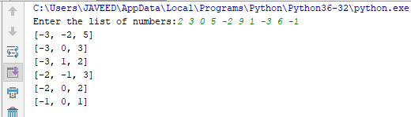

1. **Consider the following scenario. You have a list of students who are attending class “Python” and another list of students who are attending class “WebApplication”.Find the list of students who are attending both the classes. Also find the list of students who are not common in both the classes. Print it.**

**Source Code:**

python = [**'a'**,**'b'**,**'c'**,**'d'**,**'e'**,**'f'**,**'g'**,**'h'**] *#defining list of students in python class*webapp = [**'a'**,**'c'**,**'f'**,**'h'**,**'j'**,**'k'**,**'i'**,**'t'**] *#defining list of students in webapp class***def** students(python,webapp): *#function for finding the list of common and uncommon Students* common = set(python)&set(webapp) *#applying AND operator to find the commons* uncommon = set(python)^set(webapp) *#applying OR operator to find the uncommons* print(*"Students enrolled in both classes are:"*,common)  
 print(uncommon)  
students(python,webapp)

**Output:**

